***Sec. 6-1 (p.314)***

|  |  |
| --- | --- |
| **24.** | ***find the area under the standard normal distribution curve.***  To the right of (在…的右邊) 𝒛 = −𝟏. 𝟗𝟐 |

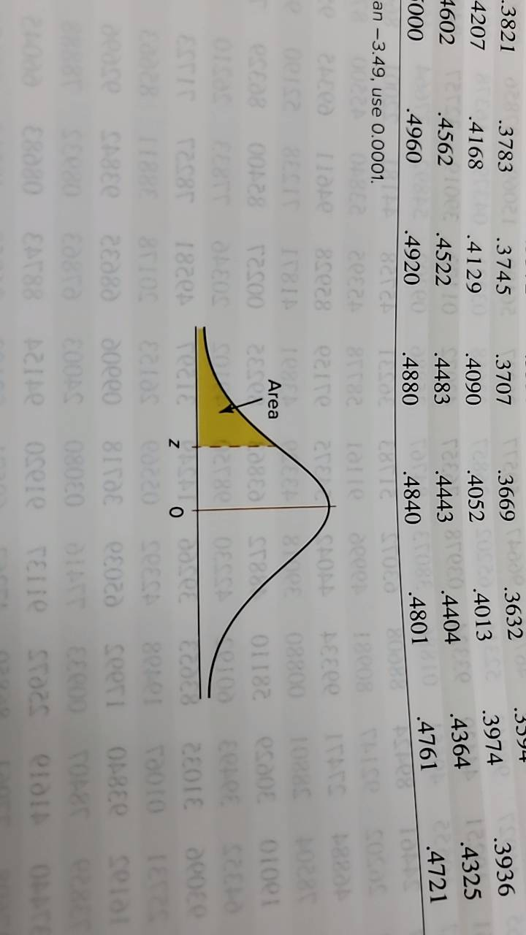

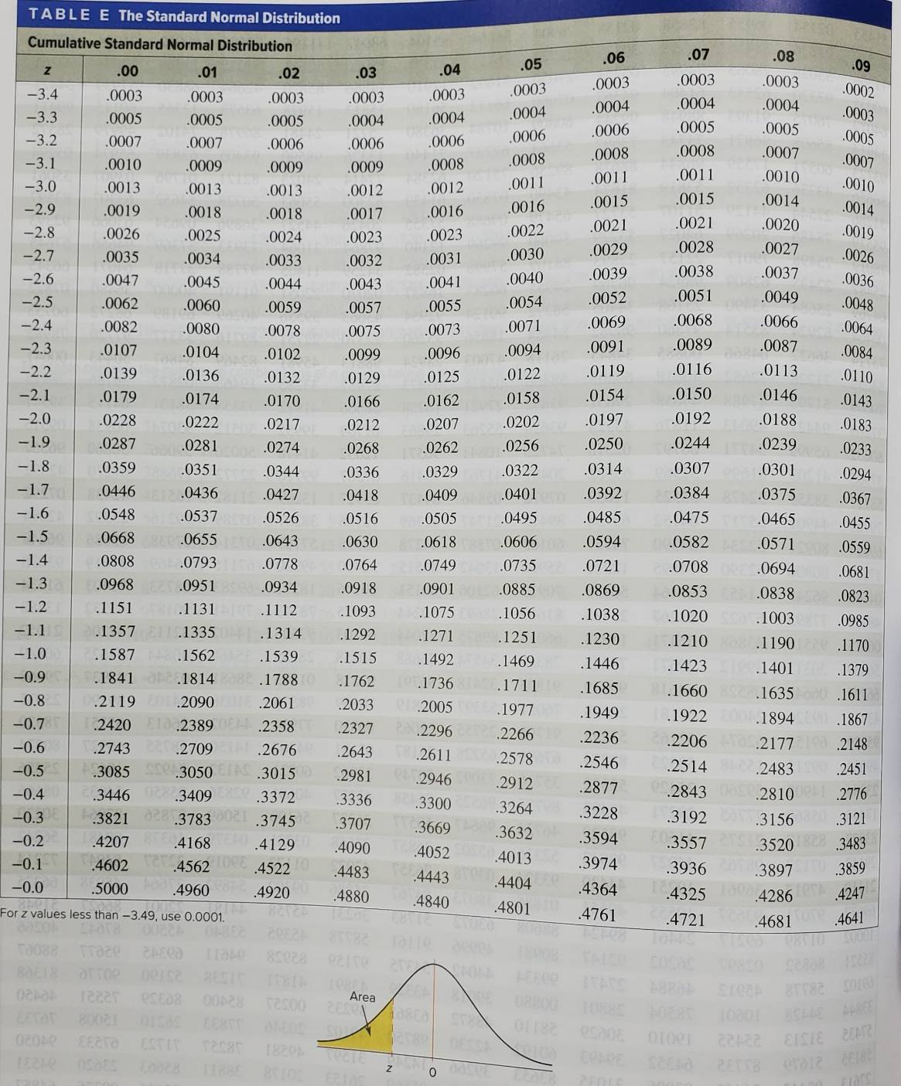



Note: 課本的查表給的機率是z左邊的面積

|  |  |
| --- | --- |
| **38.** | ***find the probabilities for each, using the standard normal distribution.***  𝐏(𝟏. 𝟏𝟐 < 𝐳 < 𝟏. 𝟒𝟑) |

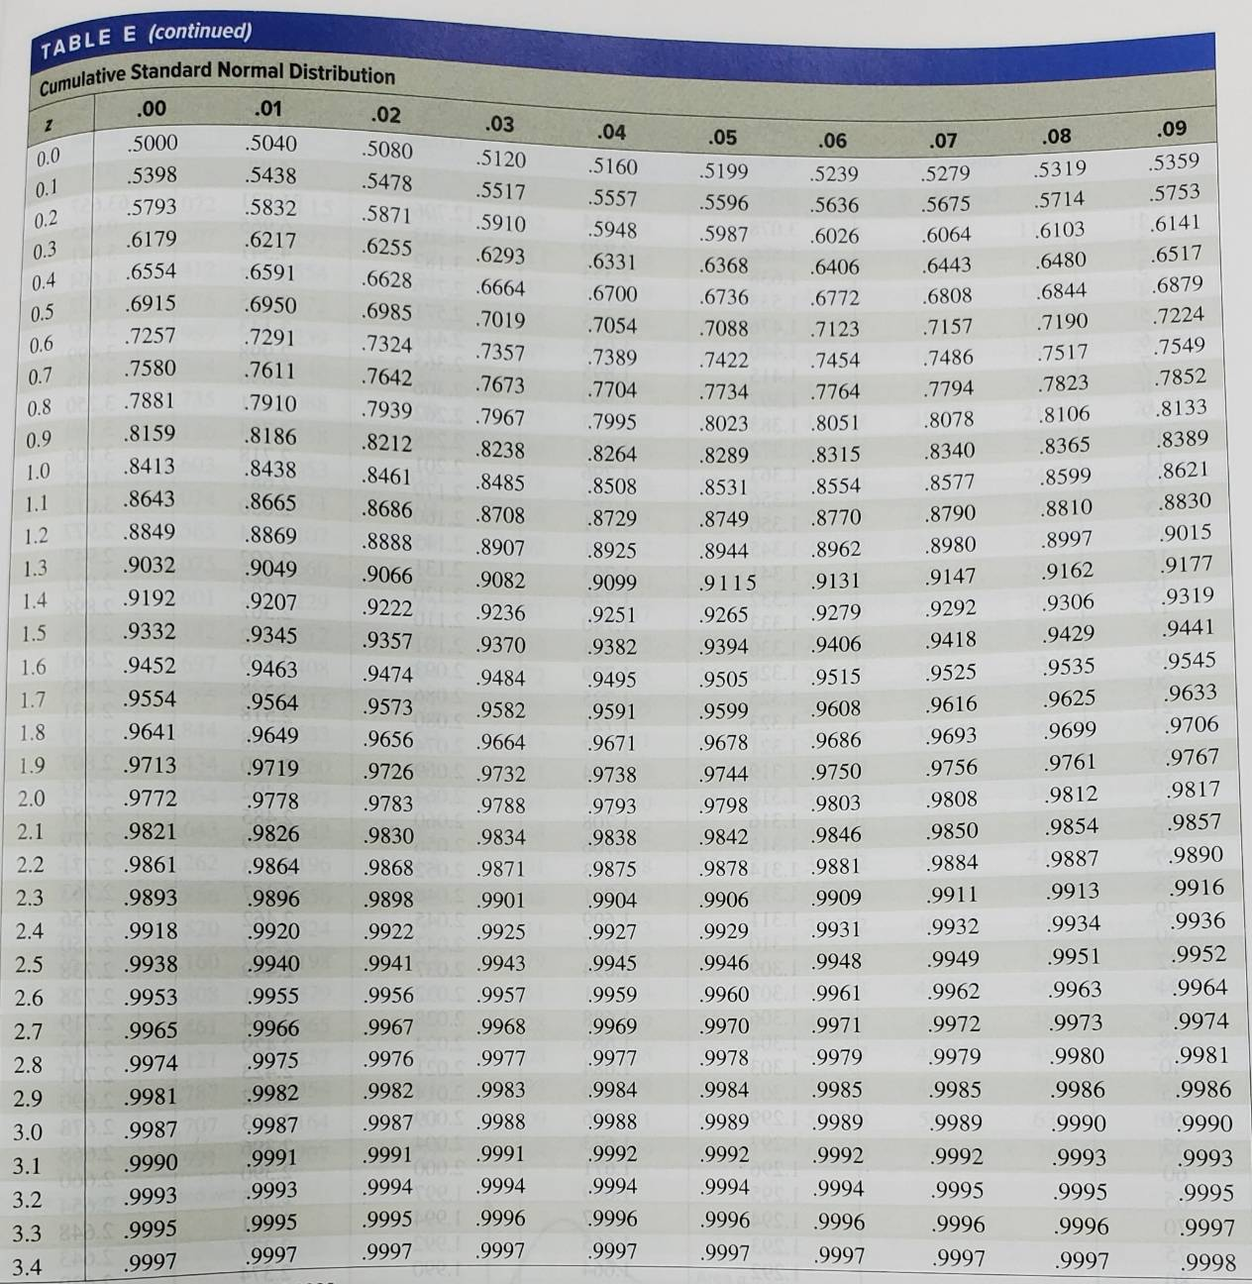

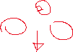

|  |  |
| --- | --- |
| **45.** | ***find the z value that corresponds to the given area.*** |

**Method 1:**

z值左邊的面積







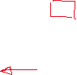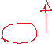

**Method 2:**



因為它是對稱的，所以也可以看成這樣



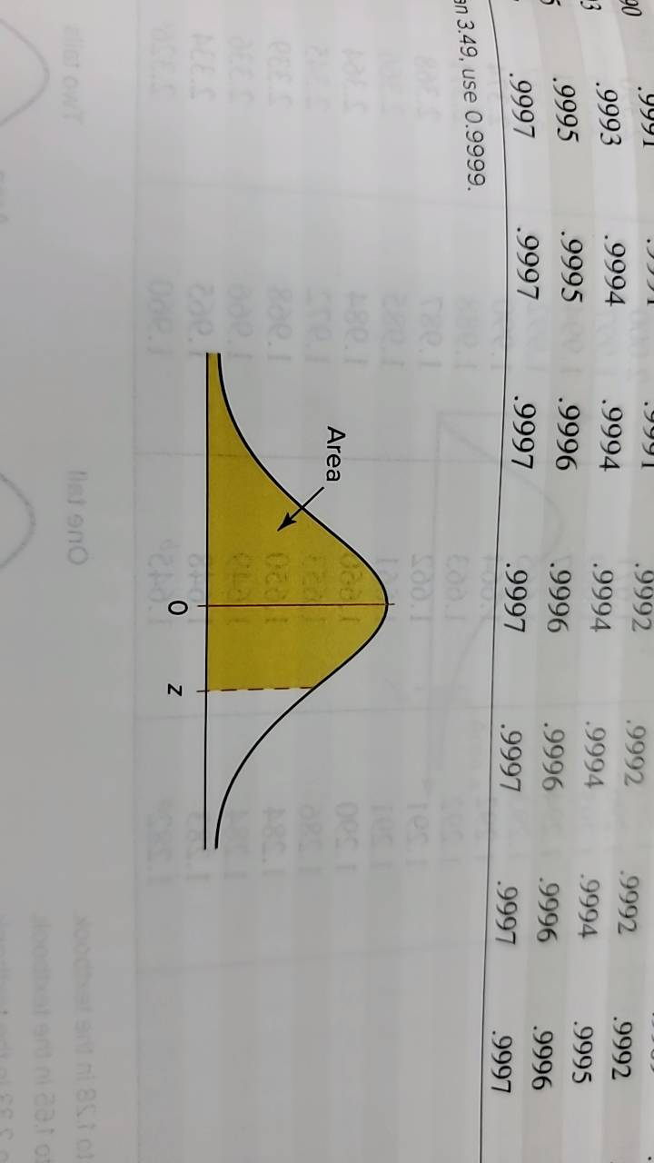











，注意這是在平均右邊的z，題目要的是左邊的，所以要加上負號

|  |  |
| --- | --- |
| **48.** | Find the z value to the right of the mean so that   1. 54.78% of the area under the distribution curve lies to the left of it. 2. 69.85% of the area under the distribution curve lies to the left of it. 3. 88.10% of the area under the distribution curve lies to the left of it. |







|  |  |
| --- | --- |
| **50.** | Find two z values so that 48% of the middle area is bounded by them. |

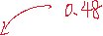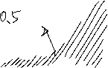

|  |  |
| --- | --- |
| Method 1:  面積  其中一邊的面積 (因為對稱) | Method 2:  平均左右兩邊面積各為0.5  黃色面積的左右兩邊各為  所以z左邊的面積 |

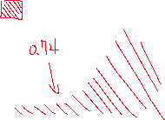

Method 1 查表



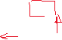





Method 2 查表







***Sec. 6-2 (p.329)***

|  |  |
| --- | --- |
| **8.** | Full-time Ph.D. (常規全日制博士項目) students receive an average of $12,837 per year. If the average salaries are normally distributed with a standard deviation of $1500, find these probabilities.   1. The student makes more than $15,000. 2. The student makes between $13,000 and $14,000. |

|  |  |
| --- | --- |
| **12.** | The average retail price of gasoline for 2014 was 342 cents. What would the standard deviation have to be in order for there to be 15% probability that a gallon of gas costs less than $3.00? |

* 1 美分 = 0.01 美元

|  |  |
| --- | --- |
| **20.** | If the average price of a new one-family home (單戶住宅) is $246,300 with a standard deviation of $15,000, find the minimum and maximum prices of the houses that a contractor (承包商) will build to satisfy the middle 80% of the market. Assume that the variable is normally distributed. |

Max = $265,500, min = $227,100

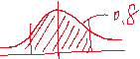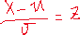

|  |  |
| --- | --- |
| **26.** | A mandatory competency test (必修能力測試) for high school sophomores (高二) has a normal distribution with a mean of 400 and a standard deviation of 100.   1. The top 3% of students receive $500. What is the minimum score you would need to receive this award? 2. The bottom 1.5% of students must go to summer school. What is the minimum score you would need to stay out of this group? |

|  |  |
| --- | --- |
| **31.** | In the distributions shown, state the mean and standard deviation for each.  Hint: See Figures 6-4 and 6-6. Also the vertical lines are 1 standard deviation apart. |

1. Mean = 120, standard deviation = 20
2. Mean = 15, standard deviation = 2.5
3. Mean = 30, standard deviation = 5

|  |  |
| --- | --- |
| **34.** | If a distribution of raw scores were plotted and then the scores were transformed to z scores, would the shape of the distribution change? Explain your answer |

No, the shape of the distributions would be the same, since z scores are raw scores scaled by the standard deviation.

(不會改變，分佈的形狀是相同的，因為 z 分數是按標準差縮放的原始分數。)

|  |  |
| --- | --- |
| **36.** | In a normal distribution, find 𝛍 when 𝛔 is 6 and 3.75% of the area lies to the left of 85. |

|  |  |  |  |  |  |  |  |  |  |  |  |  |  |  |  |  |  |  |  |
| --- | --- | --- | --- | --- | --- | --- | --- | --- | --- | --- | --- | --- | --- | --- | --- | --- | --- | --- | --- |
| **42.** | The data shown represent the number of runs made each year during Bill Mazeroski's career. (職業生涯每年的得分次數) Check for normality.   |  |  |  |  |  |  |  |  |  | | --- | --- | --- | --- | --- | --- | --- | --- | --- | | 30 | 59 | 69 | 50 | 58 | 71 | 55 | 43 | 66 | | 52 | 56 | 62 | 36 | 13 | 29 | 17 | 3 |  | |

* Histogram

次數分配表，畫5組 (不要畫太少，奇數比較好)

Range = 71 – 3 = 68, 68 / 5 = 13.6 width = 14

|  |  |  |  |  |  |  |  |  |  |  |  |  |  |  |
| --- | --- | --- | --- | --- | --- | --- | --- | --- | --- | --- | --- | --- | --- | --- |
| |  |  | | --- | --- | | Class | Freq. | | 3 – 16 | 2 | | 17 – 30 | 3 | | 31 – 44 | 2 | | 45 – 58 | 5 | | 59 – 72 | 5 |   資料為左偏 |  |  |

|  |  |  |  |  |  |  |  |  |  |  |  |  |  |  |  |  |
| --- | --- | --- | --- | --- | --- | --- | --- | --- | --- | --- | --- | --- | --- | --- | --- | --- |
| 3 | 13 | 17 | 29 | 30 | 36 | 43 | 50 | 52 | 55 | 56 | 58 | 59 | 62 | 66 | 69 | 71 |

n= 17

接近資料有偏斜

* Outlier

沒有離群值

資料不是常態

***Sec. 6-3 (p.344)***

|  |  |
| --- | --- |
| **8.** | A survey found that the American family generates an average of 17.2 pounds of glass garbage each year. Assume the standard deviation of the distribution is 2.5 pounds. Find the probability that the mean of a sample of 55 families will be between 17 and 18 pounds. |

|  |  |
| --- | --- |
| **12.** | The average teacher's salary in North Dakota (北達科他州) is $37,764. Assume a normal distribution with 𝛔 = $𝟓𝟏𝟎𝟎.   1. What is the probability that a randomly selected teacher's salary is greater than $45,000? 2. For a sample of 75 teachers, what is the probability that the sample mean is greater than $38,000? |

|  |  |
| --- | --- |
| **18.** | The average yearly Medicare Hospital Insurance benefit (醫院保險福利) per person was $4064 in a recent year. If the benefits are normally distributed with a standard deviation of $460, find the probability that the mean benefit for a random sample of 20 patients is   1. Less than $3800 2. More than $4100 |

|  |  |
| --- | --- |
| **22.** | Assume that the mean systolic blood pressure (收縮壓) of normal adults is 120 millimeters of mercury (mm Hg) (毫米汞柱) and the standard deviation is 5.6. Assume the variable is normally distributed.   1. If an individual is selected, find the probability that the individual's pressure will be between 120 and 121.8 mm Hg. 2. If a sample of 30 adults is randomly selected, find the probability that the sample mean will be between 120 and 121.8 mm Hg. 3. Why is the answer to part a so much smaller than the answer to part b? |

1. 因為a的標準差大，所以Z比較小，所以它的機率比較小

|  |  |
| --- | --- |
| **25.** | On the Trends in International Mathematics and Science Study (TIMSS, 國際數學與科學教育成就趨勢調查) test in a recent year, the United States scored an average of 508 (well below South Korea, 597; Singapore, 593; Hong Kong, 572; and Japan, 570). Suppose that we take a random sample of United States scores and that the population standard deviation is 72. If the probability that the mean of the sample exceeds 520 is 0.0985, what was the sample size? |

(樣本數要無條件進位)